Game Design Document

Fill up the Following document

1. Write the title of your project.

Vollyball game

1. What is the goal of the game?

The goal is to reach 25 scores before the opposite team

1. Write a brief story of your game?

In this story there two teams competing to win.the teams consist of 6 players each and fb it reaches to deuce at 24 24 you have to reach 2 consecutive points to win

1. Which are the playing characters of this game?

* Playing characters are the ones which respond to the user based on the input from the user
* Cars, monkeys, dinos, wizards etc, are the playing characters in the game.

|  |  |  |
| --- | --- | --- |
| Number | Character Name | What can this character do? |
| 1 | sam | Spike,ace |
| 2 | minter | Middle blocker |
| 3 | harry | Captain/defend |
| 4 | manny | libro |
| 5 | freezy | blocker |
| 6 | tobi | setter |
| 7 |  |  |
| 8 |  |  |

1. Which are the Non Playing Characters of this game?

* Non Playing characters are the ones which don't have an action or a behaviour when the user interacts with the game.
* Hurdles, stones, bananas, coins, etc are non playing characters in the game.

|  |  |  |
| --- | --- | --- |
| Number | Character Name | What can this character do? |
| 1 | none |  |
| 2 |  |  |
| 3 |  |  |
| 4 |  |  |
| 5 |  |  |
| 6 |  |  |
| 7 |  |  |
| 8 |  |  |

Draw your imagination of this game. What does this game look like?

* Draw the game either on your computer or on paper,
* Add images of scenes of the game to show each of the playing and non-playing characters at least once.

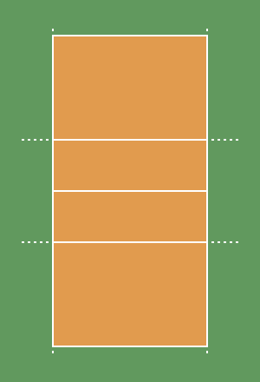

[This Photo](http://commons.wikimedia.org/wiki/File:VolleyballCourt0.png) by Unknown Author is licensed under [CC BY-SA](https://creativecommons.org/licenses/by-sa/3.0/)

How do you plan to make your game engaging?

I want to make the players move if they touch the ball the ball shoud go back and if it drops there is a pint for the opposite team